Generating training labels for first training round using MIB and WEKA

- Generating labels—using Example labels (i.e. Tr1)-- slices 9-11
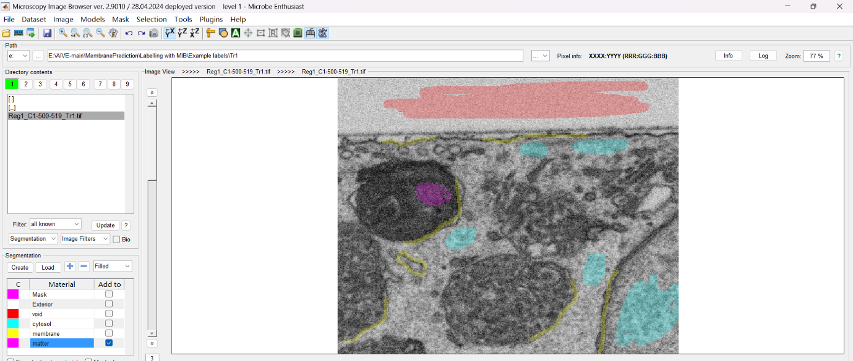

- When saved as sequence of 2D files, there will be 3 files
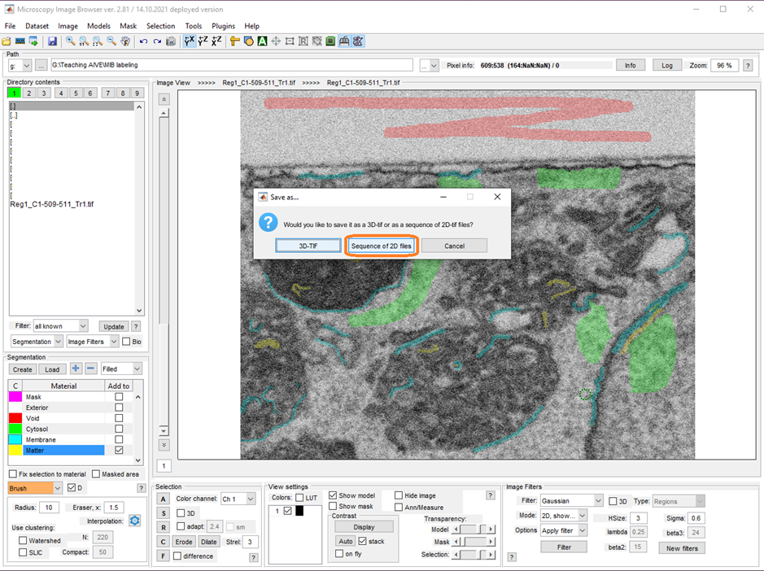
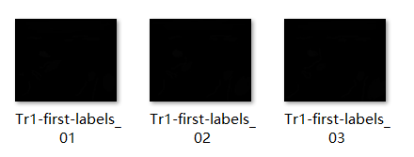
- The folder with these 3 files is the second box of Core A macro. The first box is the 3 feature stacks in previous steps.
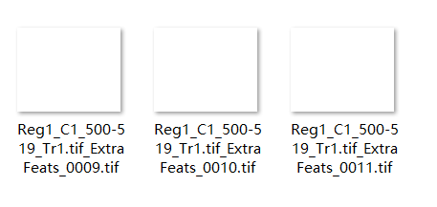
- Then the output is a Weka compatible labels file, then open in Weka
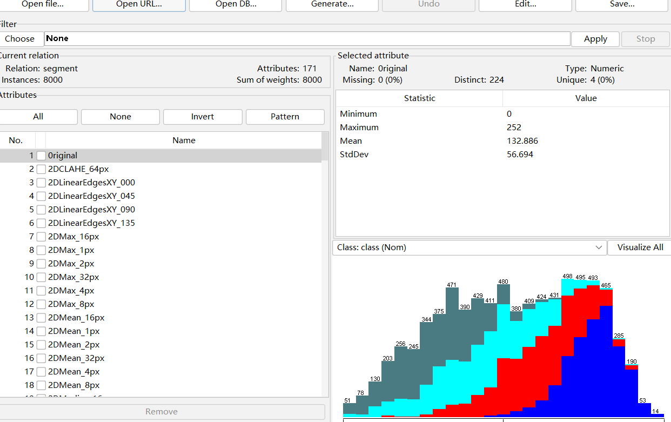
- Switch to the classify tab to set up training. Choose Random forest and use cross-validation with 10 folds and hit start.
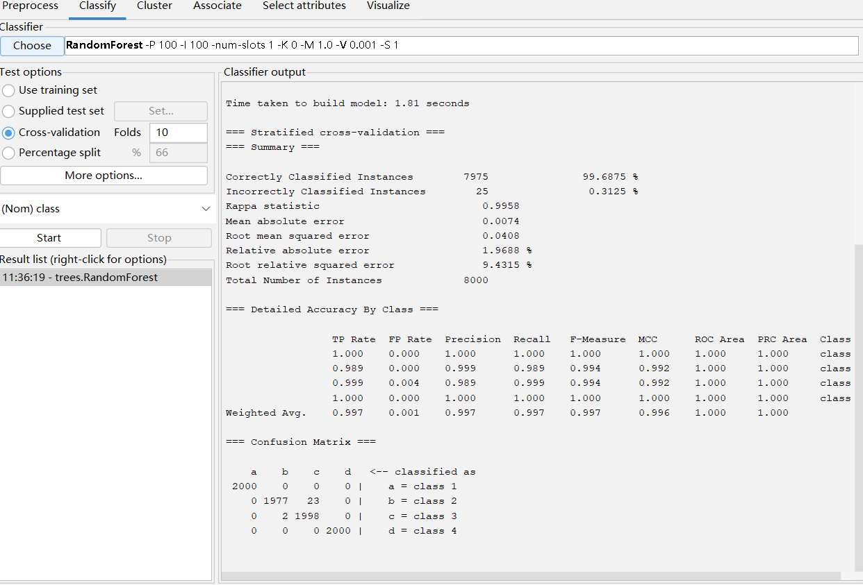

Note:
- Wrong input for the second box of Core A macro
E:\AIVE-main\MembranePrediction\Labelling with MIB\Example labels\Tr1 MIB labels ->this is not a sequence of 2D images.
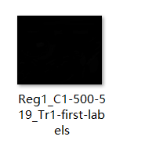
Output: the output file is empty

- Wrong input for the first box of Core A macro
E:\AIVE-main\MembranePrediction\FeatureStackGeneration\Merge -> this contains more than 3 slices of features
Output: a wrong Weka compatible labels file
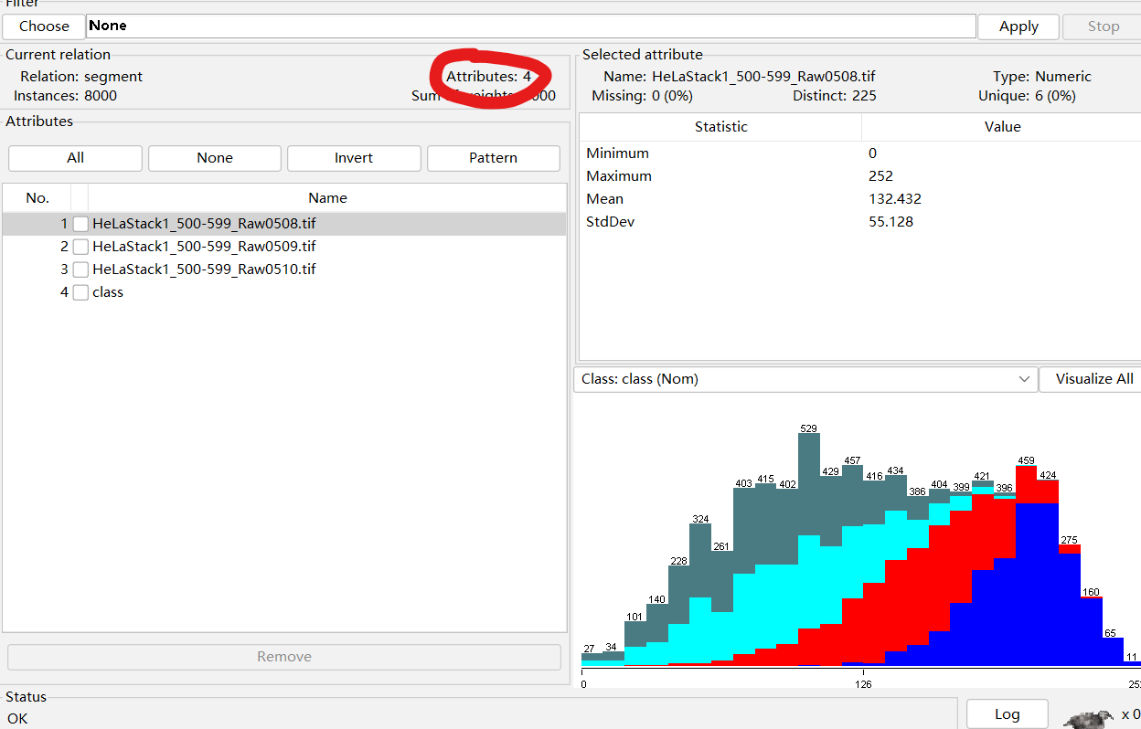
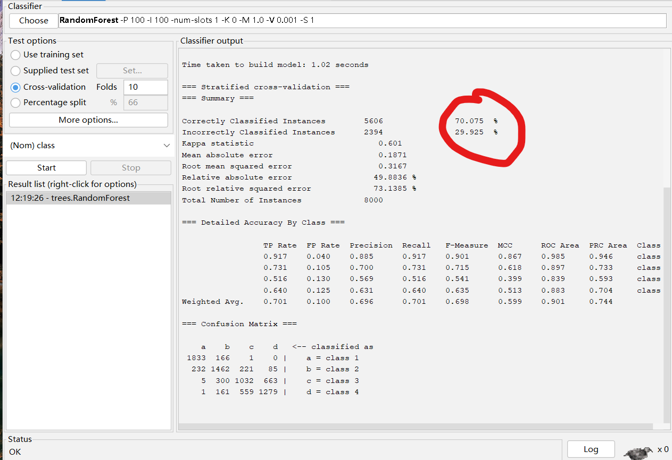
And the steps of generating hyper stack can not be continued.

